**MLOPS**

**IMDB MLFLOW**

LSTM EXPRESSION

Comparing Lstm runs

Confusion matrix

Precision recall curve

ROC Curve

Logistic Regression EXPERIMENT

Confusion Matrix of best Model

ROC Curve

Test classification report

Comparing Runs

Confusion matrix

Roc Curve

Precision Recall Curve

Test classification report

XGBoost Experiment

Comparing runs

Confusion Matrix

ROC

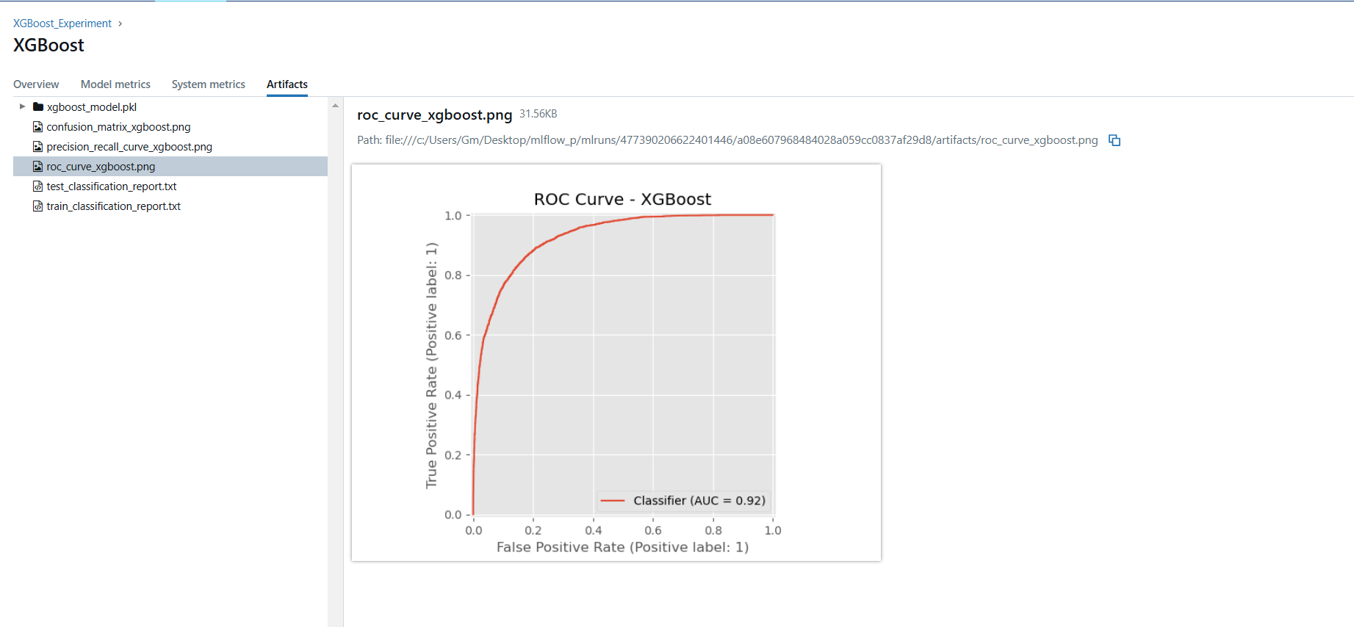

Test classification Report

